**Heroes of Pymoli Data Analysis**

After looking at the Heroes of Pymoli data there are many conclusions we can draw. For instance, it is notable that over 84% of all active players are male.

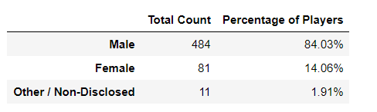

Another interesting point that we see is that females spend on average $0.40 more than males. This is interesting to note as advertising more towards females could increase revenue.

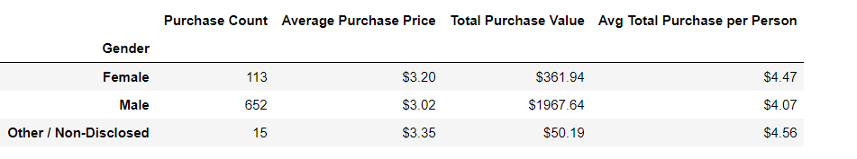

Still looking at revenue, we can also see that kids less than 10 years old, and adults between 35-39 are also the biggest spenders per person.

